

SUBMITTED TO: MR. MUBASHIR IQBAL
SUBMITTED BY: AHMED SALEEM RANA
_{REG ID: 24-CYS-023}
_{SECTION: B}

_{HITEC UNIVERSITY TAXILA, CANTT}
TASK 01
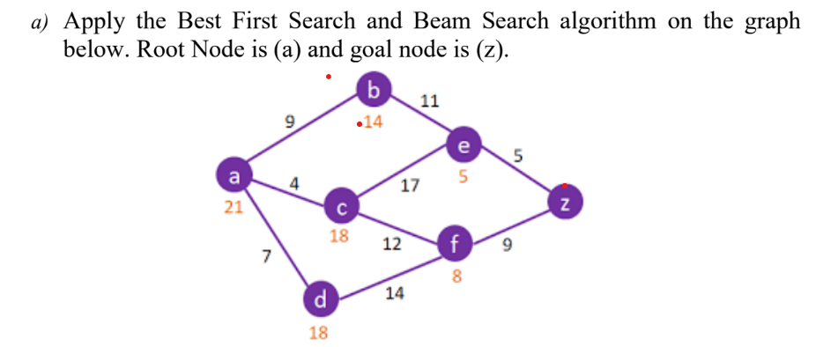
PART A:
BFS - CODE:
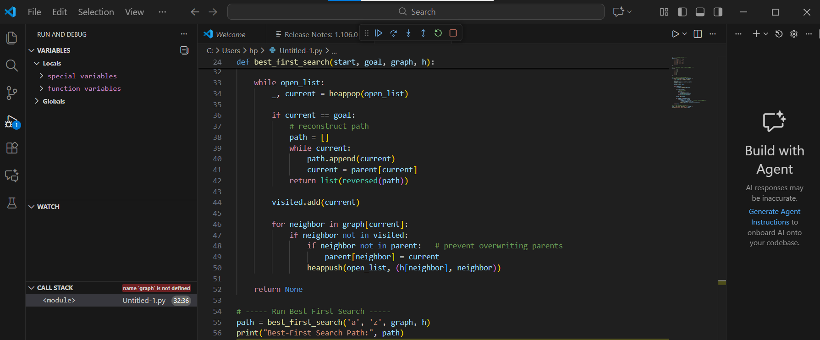
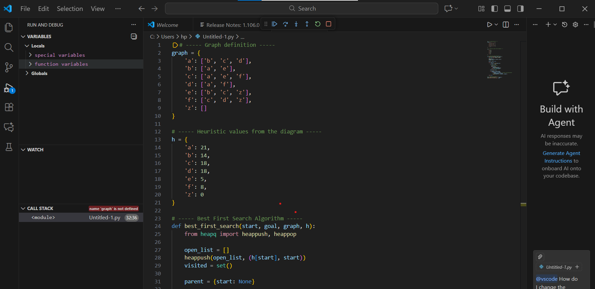
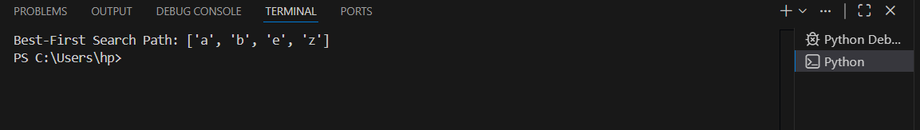
OUTPUT:
BEAM SEARCH ALGORITHM CODE:
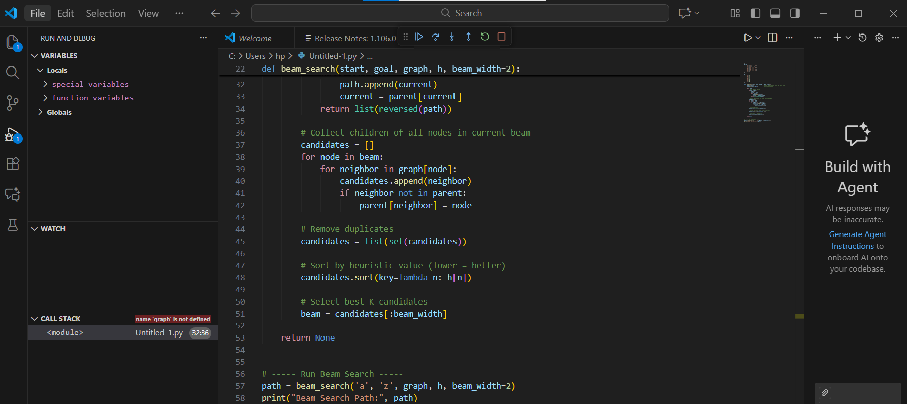
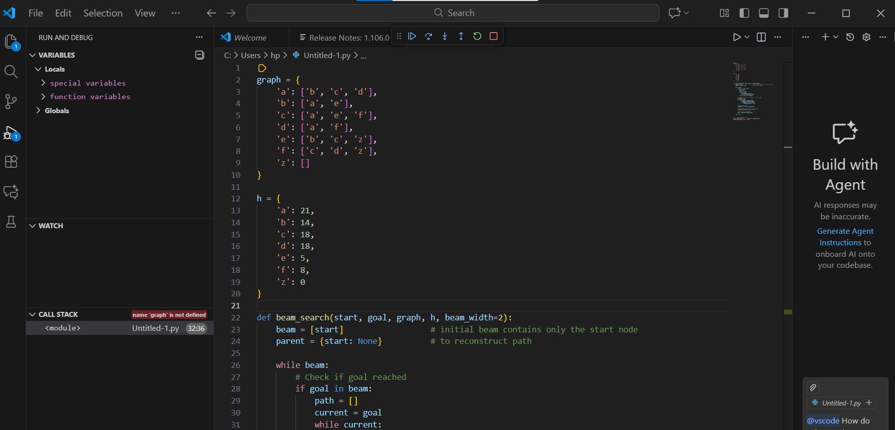
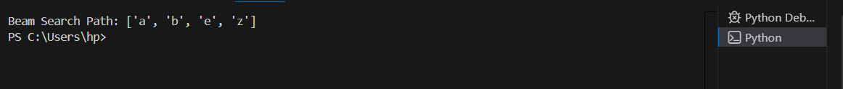
OUTPUT:
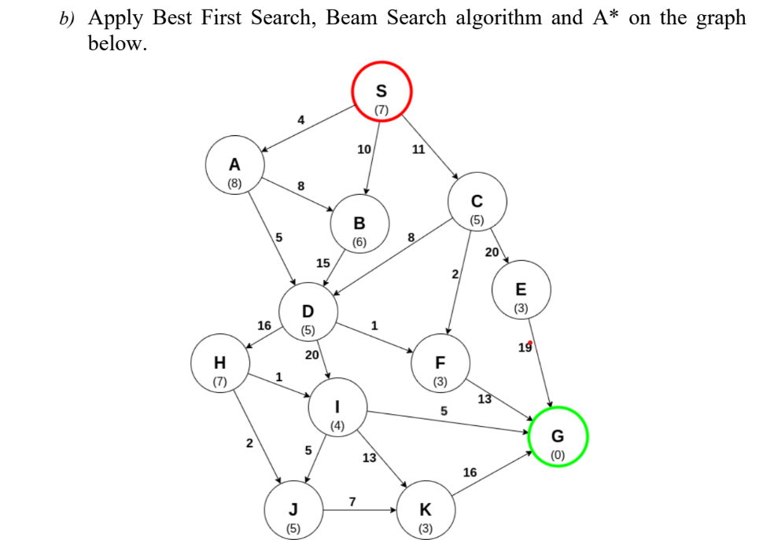
PART B

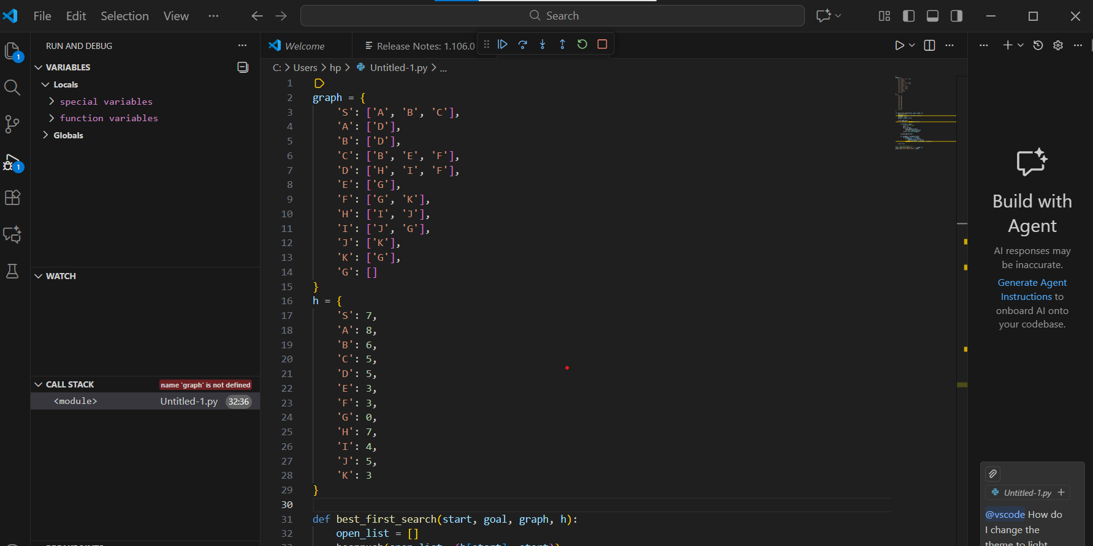
BFS – CODE:

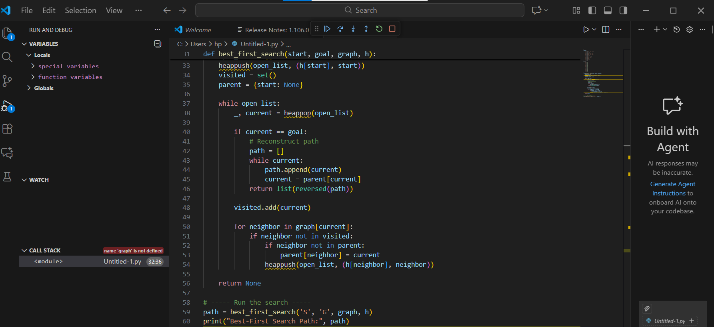
OUTPUT:
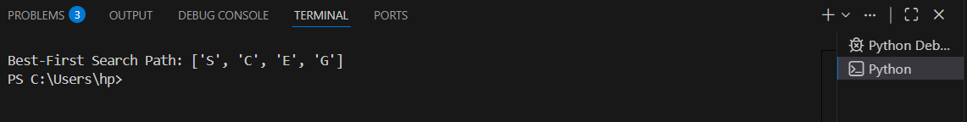
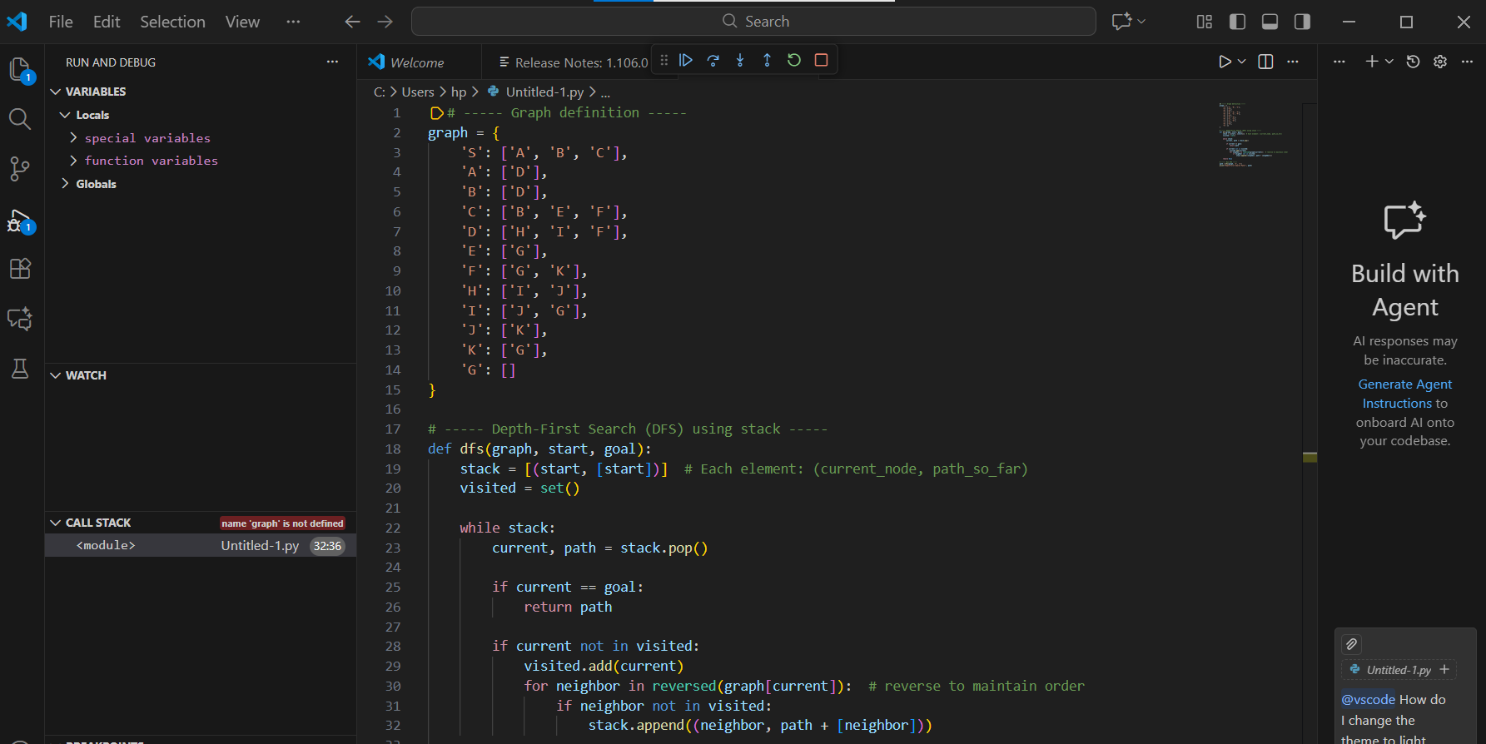
DEEP SEARCH ALGORITHM CODE:
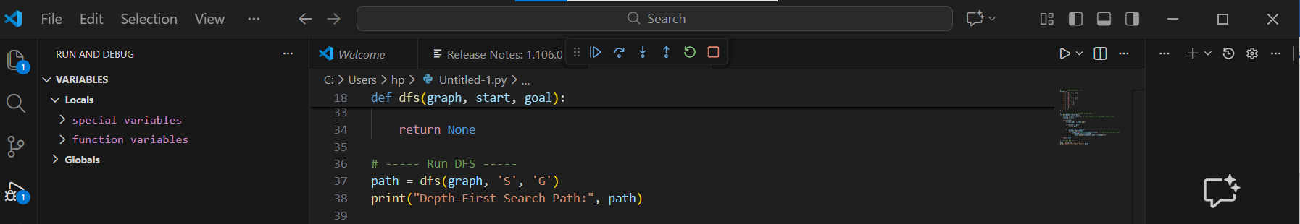
OUTPUT:
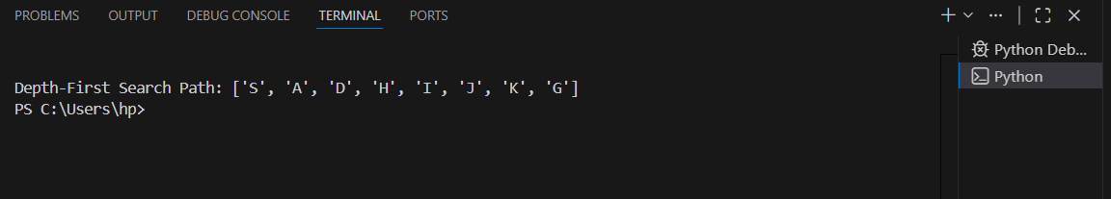

CONCLUSION:
We have applied several search algorithms on two different graphs to identify paths from the start to the goal. In the first graph, Best-First Search (DFS) algorithm is used which relies on heuristics to prioritize nodes closer to the goal, while Beam Search algorithm restricted the number of nodes explored at each level to find a path efficiently. In the second graph, we implemented Depth-First Search (DFS), which traversed the graph deeply before backtracking, successfully reaching the goal node 'S' to 'G'.

